MARS - Create New Report
Work Instruction
Purpose
This work instruction is used to:
- Create and format a new report
- Modify the query with new data elements
- Save the report to My Folders
- Schedule the report to be sent in an email
Prerequisites
- User must be a registered MARS user
- Log into the MIP with your user name and password
Navigation
Via Menu Path | Home ➔ MARS tab  then  Log in to MARS
Work Steps
1. Click on the tab. You must be a registered user and logged into the MIP to see the MARS tab.
2. From the MARS landing page, click on Access MARS to launch MARS in a new window. The MIP window will remain open while you are in MARS. The MARS landing page has new look.
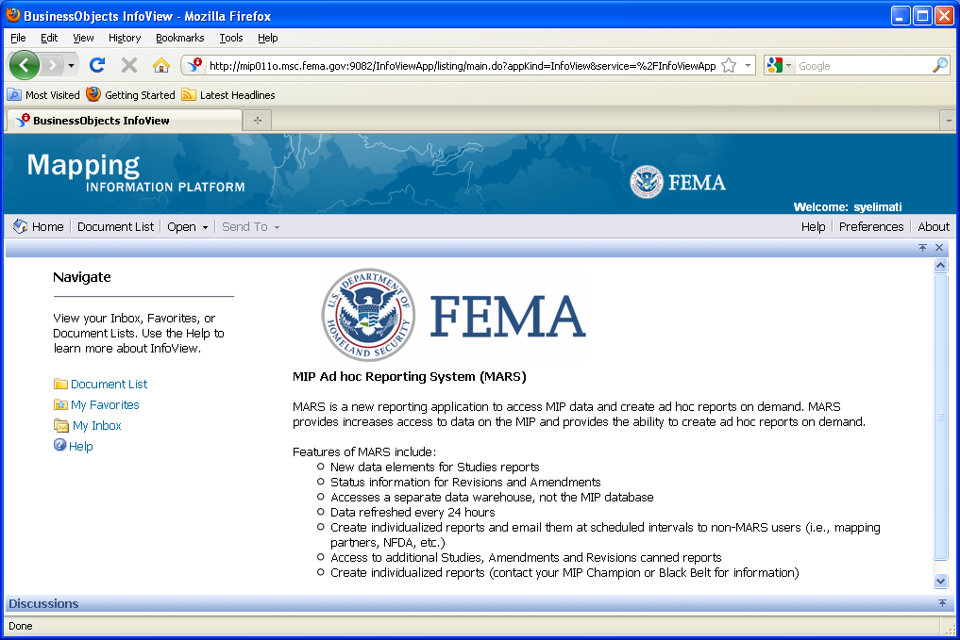

3. Click on to bring up a collection of folders used for housing reports. The Folders list shows My Folders and Public Folders.
From the Web Intelligence Document menu, click on the dropdown box to create a new report.
Create New Report
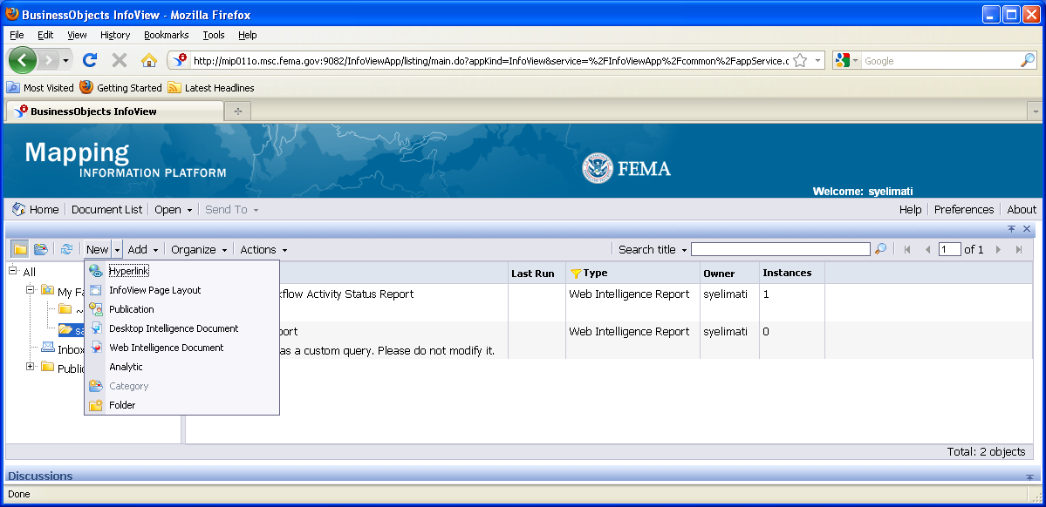

4. Select Web Intelligence Document. You can also create a new folder by selecting Folder, but you can only do that under any folder under My Folders tree.
Web Intelligence Document and Folder are the only selections we will choose from this dropdown list.
Universes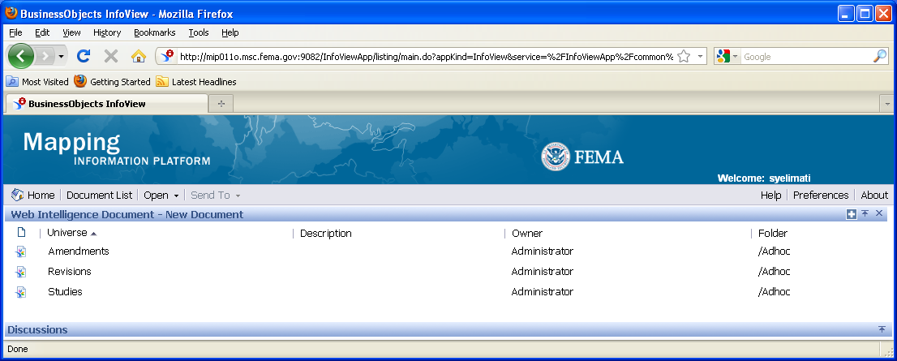
5. Select the universe (Amendments, Revisions or Studies) in which you want to create a report. You can only select one universe at a time. Once you select a universe, you will only see data elements related to that universe.
Click on the Studies link.
Build/Edit Query Screen
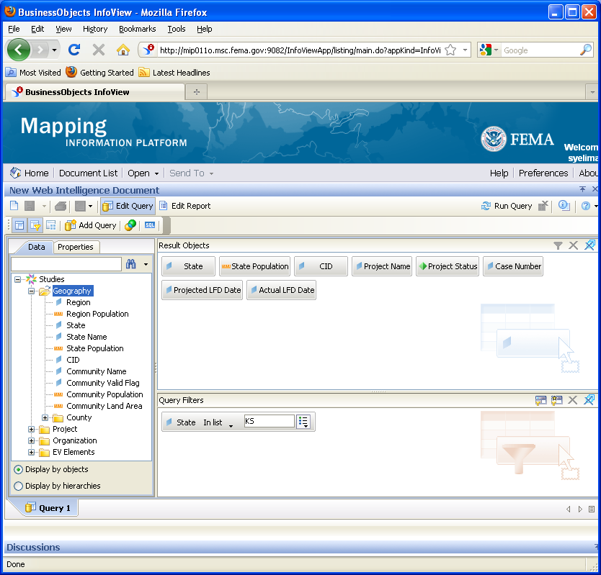

6. Navigate through the data elements list and drag and drop the data elements into the Results Objects box that you want to include in the report.
**IMPORTANT** Notice that when you drop data element marked with a green pyramid, it will always bring over the parent data element (in this example, Project Status and Project Name).
7. To filter the query, drag and drop the data element(s) to the Query Filters box.
8. Once you have set your data elements and filters, click to view the report results.
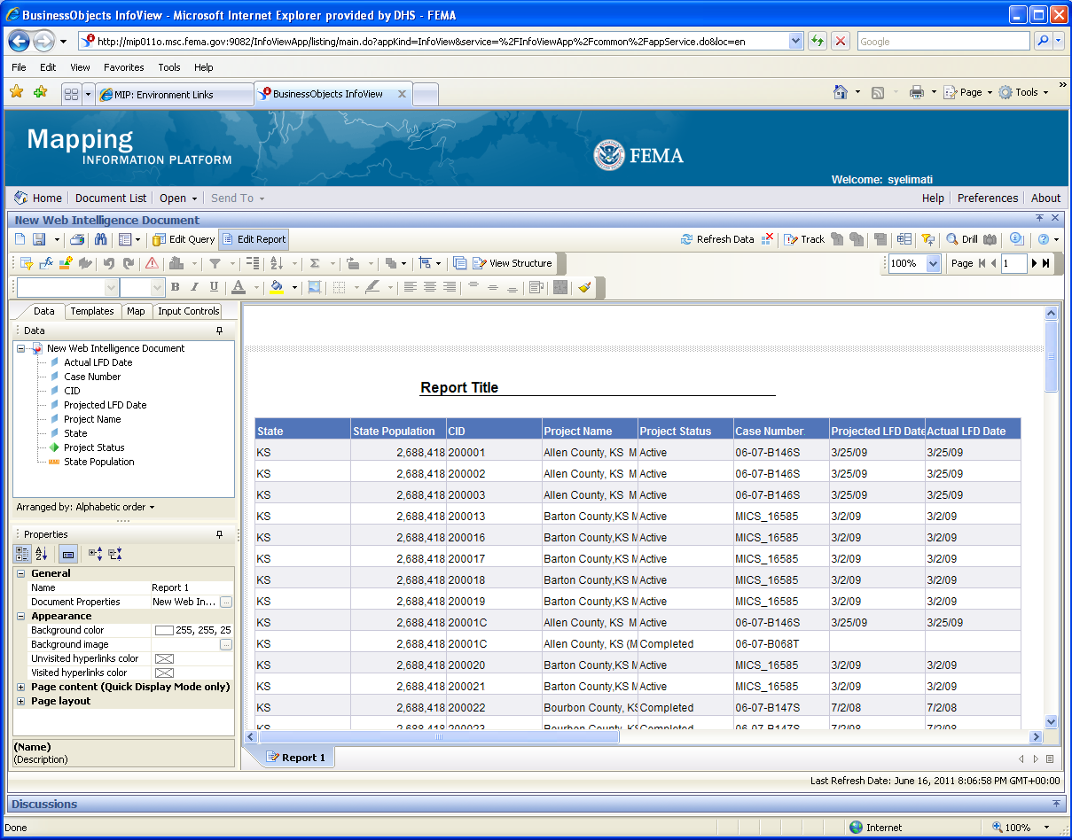
9. To remove a column from the report, click the column title and drag and drop it back to the box on the left. Or click the column title to highlight it and press Delete on your keyboard.
10. To format a column, click a row under the column title to highlight the entire column. Click the tab for options to change the format of the column.
11. Click to update the query.
12. To add additional information to this query, drag and drop additional data element(s) to the Results Query box.
13. To add additional filter(s) to this query, drag and drop the data element(s) to the Query Filter box and set the filters.
14. Click .
** IMPORTANT** The new data element(s) you added are not yet included in the report results. You now have to drag and drop the data result objects into the report between two column titles.
New Edit Query Results

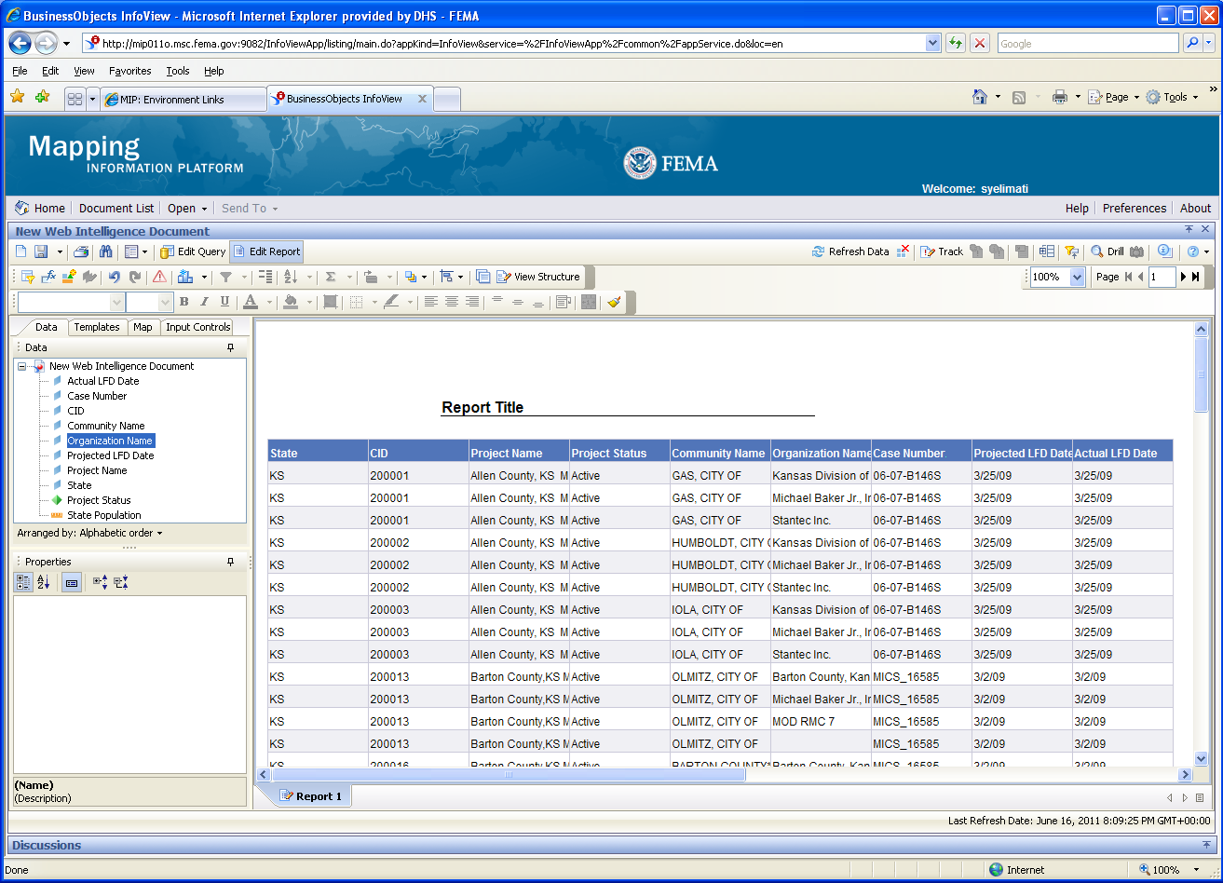
15. Click and drag the line between two columns to increase the width of the column to the left of the line.
16. Right click on any column title for more format options, including: Sort, Format Number, Remove Row/Column, etc.
17. Double click on the report title to change the report name.
18. Don't forget to save your changes! Click the dropdown box.
- Select Save as... to save the report to My Folders.
- Select Save to my computer as to save the report in a different format to your computer.
19. When you select Save as… the Save Document screen appears when you save a document to your personal folders.
Save Document Screen
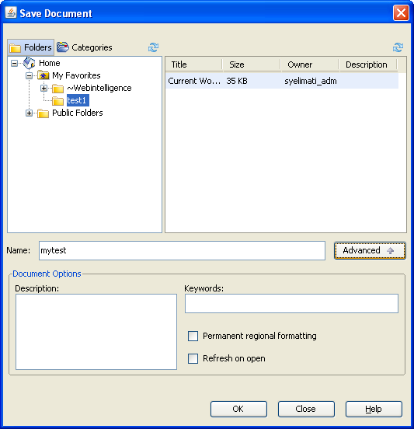

20. Enter a Title of the report. The Description and Keywords boxes visible when you click 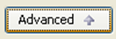 button are optional fields.
21. Click on the Refresh on open checkbox to have the data automatically refresh each time you open the report.
If this button is not checked, you will have to click the Refresh button each time you open the report to see the latest data.
Permanent Regional Formatting is not an option we will use in MARS.
22. Click on a folder under My Favorites folder to highlight that this is the folder where you want the report saved.
23. Click to save the report to that folder.
24. Click to return to Infoview folder list.
25. Click the My Favorites link to view all of your personal reports and folders.
Favorites List
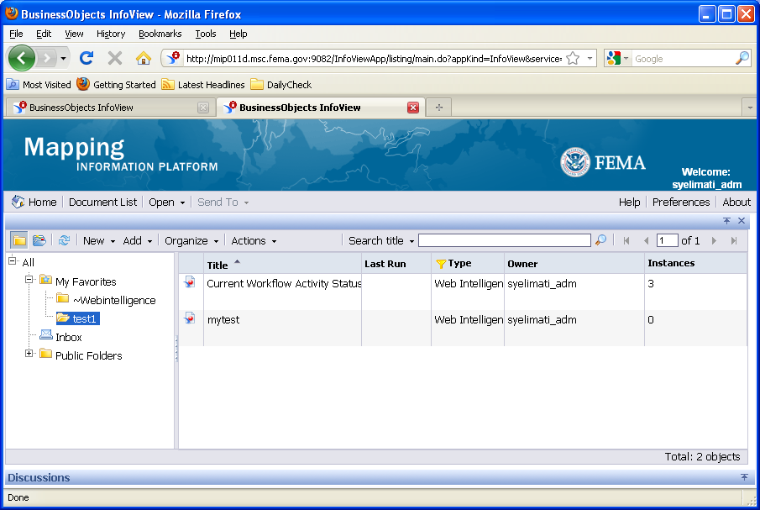

26. Right-Click and select the Schedule link to set parameters for sending the report to another user. The schedule screen appears.
Schedule Screen (1 of 2)
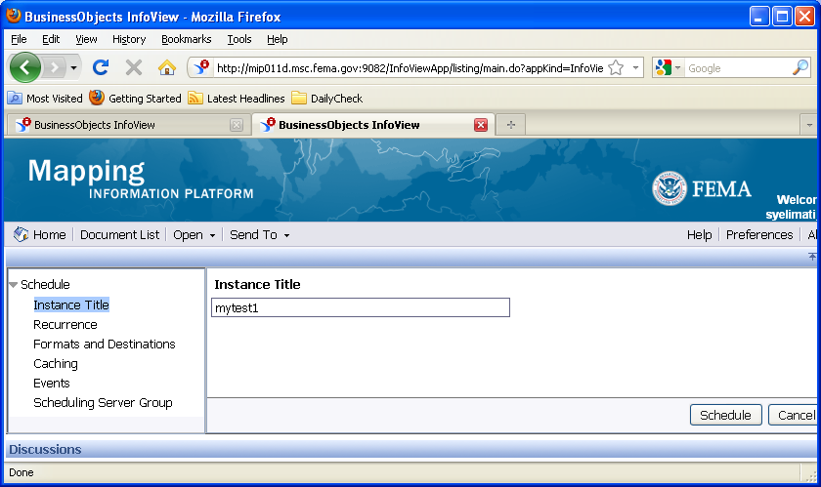

27. Insert the title for the report sending process in the Instance Title field. Click on the Recurrence link to open the Run object options for scheduling the report.
28. For this example, we selected Weekly from the Run object dropdown box. Select the day, Start Time and End Time. Click the calendar widget to set a new end date. You can also manually enter a date in the date field using the correct format.
Run object options
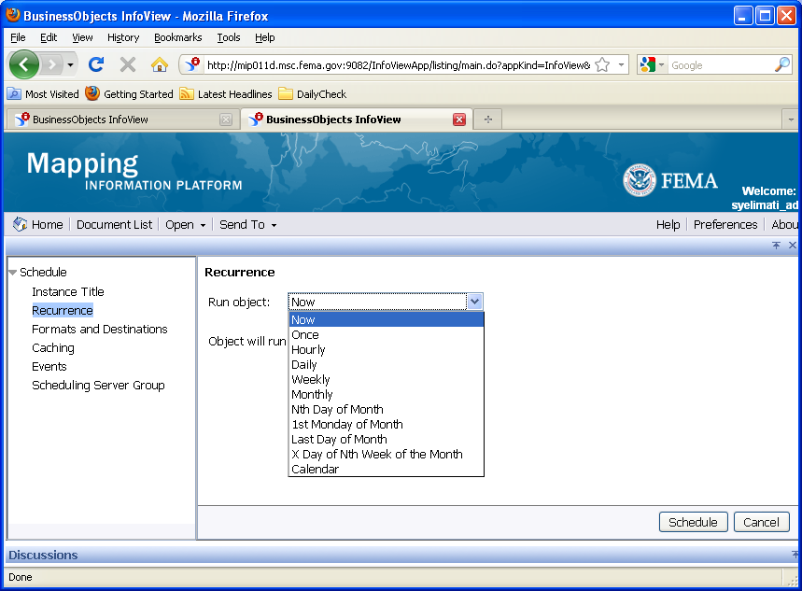
29. Click on Prompts and click on Modify to open and select prompts and apply to all scheduled reports. If there are prompts involved you may change them in the Prompts section. If not involved, then it will not be visible.
30. Click on Formats and Destinations link to open and select the Output Format. We want to add an attachment, but we cannot do that until we choose the format type. In the Formats and Destinations section, select the Output Format and Destination check-boxes to choose which Output Format to include as an attachment.
When emailing a recipient, choose either Microsoft Excel or Adobe Acrobat.
Do not select Web Intelligence if emailing the recipient. They will receive the link in their email, but the tool is not set up to work off of their email. Only select Web Intelligence if you select Inbox in the Destination.
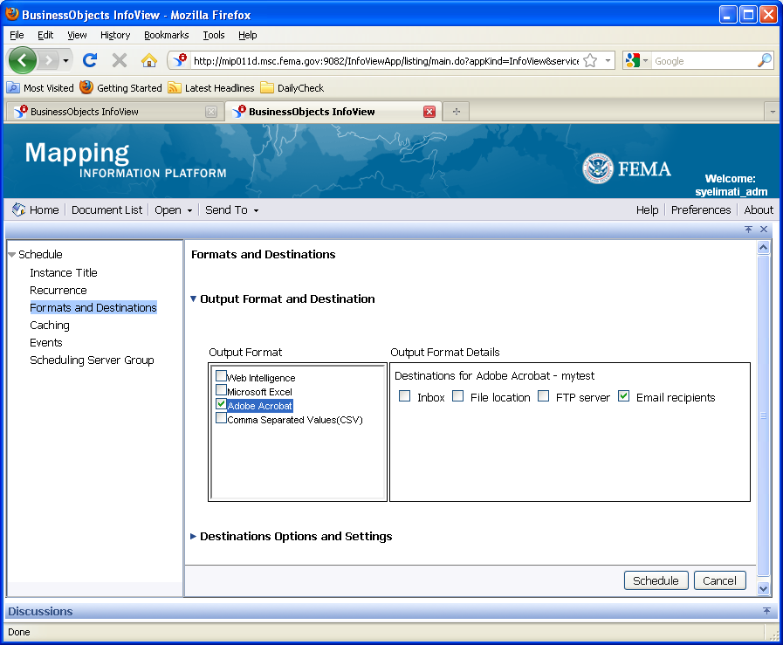
31. Click on Formats and Destinations link to open and select the Destinations for Web Intelligence checkboxes. Always choose Inbox or Email recipients.
What is the difference between Inbox and Email recipients?
Inbox - This is not the user's email inbox, but the user's MARS inbox (highlighted in red in My Folders). Use this option to send reports to other MARS users. Sending to the MARS inbox as a Web Intelligence document allows the user to modify the data elements and filters.
Email recipients - This option can be used for sending reports to other users. The report will appear as an Excel or PDF attachment in the user's regular email box.
.
32. Click the Destination Options and Settings link to open and select a destination. Uncheck, Use the Job Server's defaults. Under the Destinations Options and Settings, complete the email fields to send the report to a user.
Another option to send a report is to save the report to your computer and attach the report to a regular email message.
33. Click the Add Attachment checkbox .
Subject, (File)Name and Message support placeholder dropdowns which you may use to compose custom titles and messages with generic information like:
Subjects : <Title>, <ID>, <Owner>, <Date and Time>, <Email Address>
Message: Above plus 2 more <User Full Name>, <Viewer Hyperlink>
.
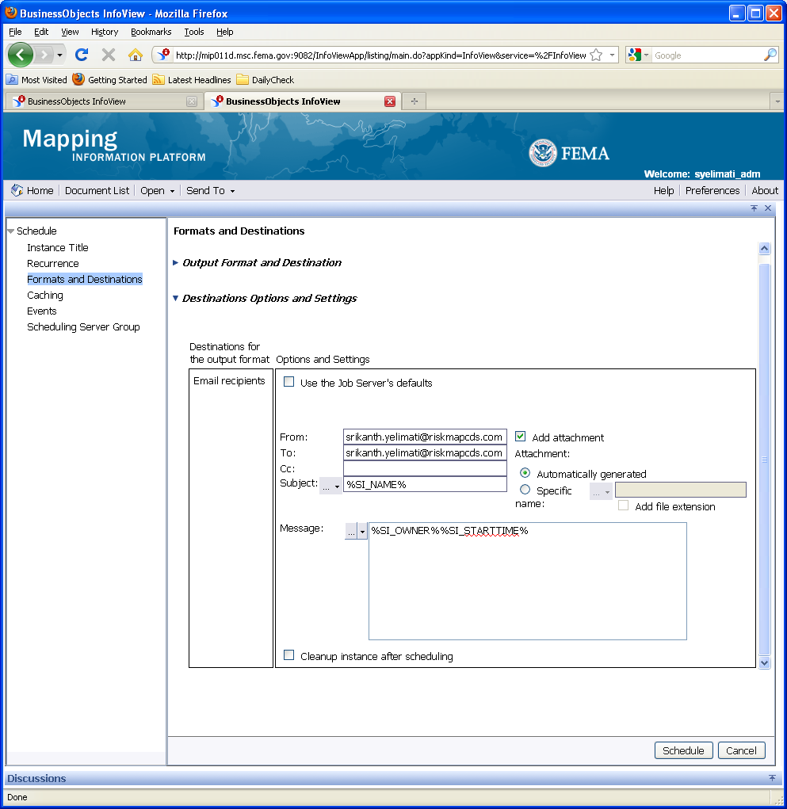

34. Keep the Add file extension box checked. This will automatically add the correct extension.
35. Keep the Add file extension box checked. This will automatically add the correct extension.
There are no settings you need to alter in the Caching, Scheduling Server Group, Events options.
36. Click to schedule the email with the added features.
37. If you decide to change the end date of the scheduled report, click the
Actions->Reschedule link to alter the settings.
Report History
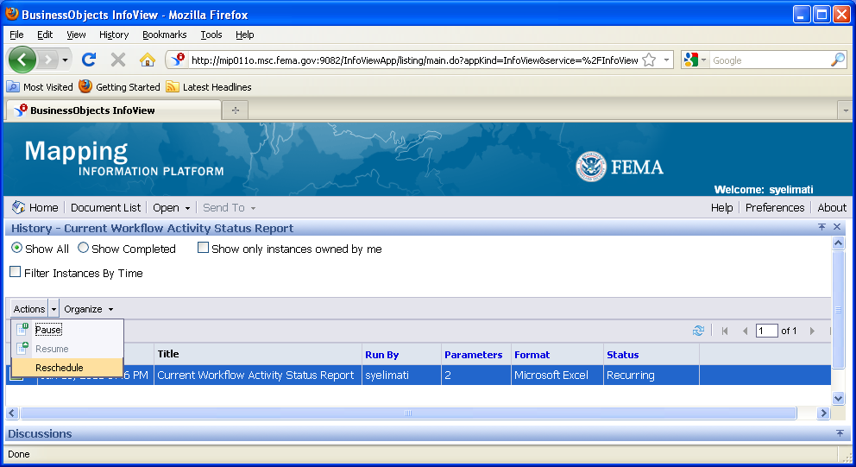

38. After rescheduling the instance, the Favorites folder now displays two similar reports. When we rescheduled the report it created a new instance. If we leave both on this list then the email recipient will receive both reports. Delete the earlier instance.
Click the checkbox to select which instance to delete.
Delete a Report
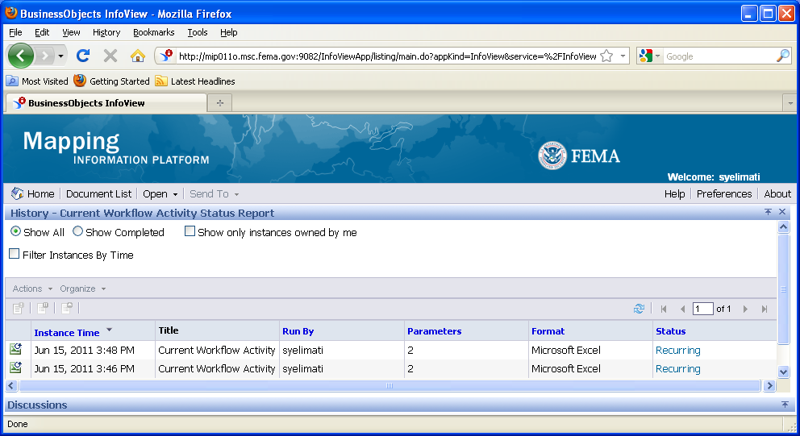

39. Click on the drop-down menu and select to remove the selected instance. Click the Recurring link to view the status and settings for this scheduled instance.
History Screen
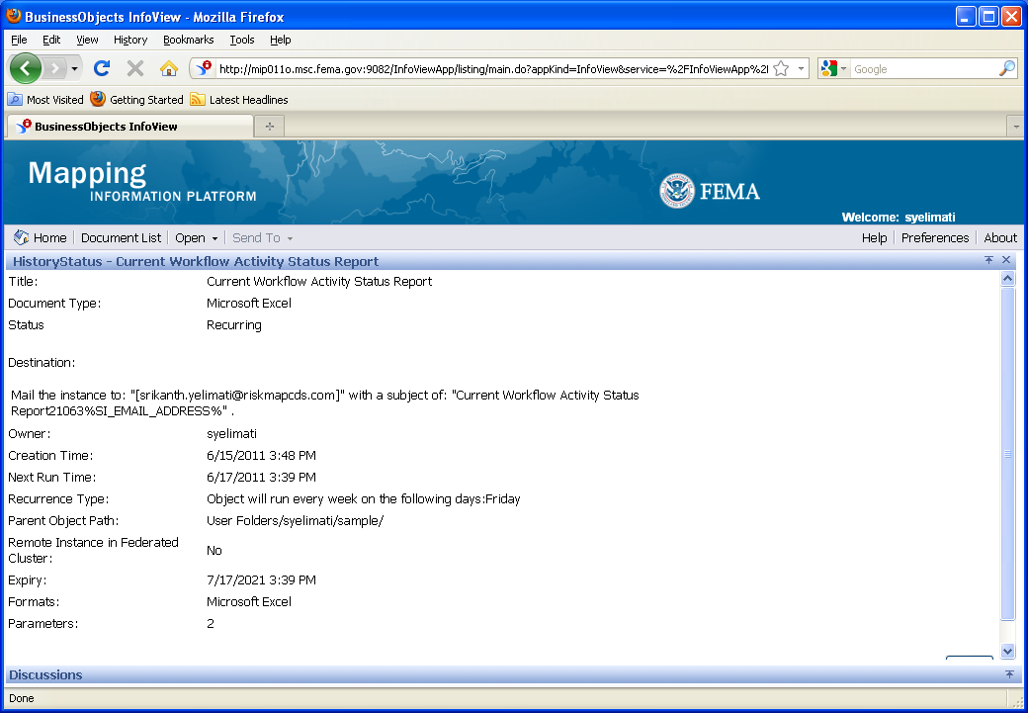
This screen provides details of where and when the report will be run and emailed.
40. Click on to return to the previous page.

Results
Congratulations! You have successfully:
- Created and formatted a new report
- Modified the query with new data elements
- Saved the report to My Folders
- Scheduled the report to be sent in an email

