

Database Exporter Tool

User Guide

FEMA DFIRM Production Tools

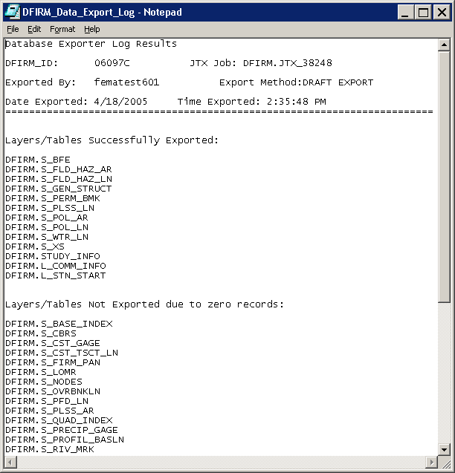

Table of Contents:

What is the Database Exporter? 3
Database Exporter Overview 3
Quick Reference Guide 3
Tool Controls 4
Submit Draft Data 4
Submit Preliminary Data 5
Submit Final Data 5
Trouble-Shooting 6
Contacts 7

What is the Database Exporter?
The Database Exporter allows users to export the populated data layers and tables from the ESRI SDE Geodatabase format into the three formats Mapping Partners are required to digitally submit to FEMA’s Map Service Center (ESRI shapefile, ESRI Arc/Info interchange file, and MapInfo interchange format). These formats are dictated by FEMA’s Guidelines and Specifications for Flood Hazard Mapping Partners, Appendix L: Guidance for Preparing Draft Digital Data and DFIRM Database. The exported data layers, tables, and log files generated by the Database Exporter are saved to the appropriate folder on the Submittal Directory (K drive).
Database Exporter toolbar

Database Exporter Overview
The Database Exporter user guide contains useful information that will help guide you through using the tool. The key sections of this guide are:
- Quick user reference guide (p. 3)
- Descriptions of tools and how to use them (p. 4)
- Support/contact information (p. 7)

Quick Reference Guide
The following is a quick reference guide to all of the components of the Database Exporter Toolbar.
 | Submit Draft Data | Export draft DFIRM data to required formats
 | Submit Preliminary Data | Export preliminary DFIRM data to required formats
 | Submit Final Data | Export final DFIRM data to required formats

Tool Controls
The DFIRM geodatabase must be submitted to FEMA in three digital data formats: ESRI shapefile (.shp); ESRI Arc/Info interchange file (.e00); and MapInfo interchange format (.mif). These formats are exported and stored when the DFIRM database is being developed (Draft Data); when the study is Preliminary (Preliminary Data); and when the study is Post-Preliminary (Final Data).

Submit Draft Data
Use this tool to export the draft version of the project data to the three required formats. The exported data files and the export log file are stored in the Submittal Directory (K drive), in the project’s Draft_DFIRM_DB folder.
- Click on the Submit Draft Data button.
- Select the project name in the dialog box and click OK.
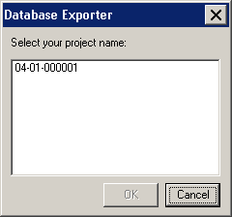
Project Selection dialog
NOTE: The data must be exported to all formats once the process is initiated, and the process cannot be canceled. The export may require a considerable amount of time, depending upon how much data exists for the project. Make sure that you are ready to start exporting before selecting your project number.
- A series of process dialogs appear, displaying the progress for each of the following steps in the database export routine:
  - Exporting feature classes to shapefiles
  - Exporting Info tables to dBase tables
  - Exporting shapefiles to coverages
  - Exporting coverage to interchange file
- Once the data has been exported to all of the file formats, a window with the exporting results log will appear. The log file lists which layers/tables were successfully exported and which failed to export because the layer or table was empty. This file is saved in the Draft_DFIRM_DB folder, with the exported data.
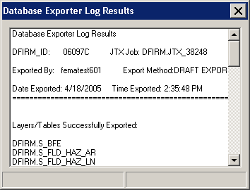
Database Exporter Results Log

Submit Preliminary Data
Use this tool to export the preliminary version of the project data to the three required formats. The exported data files and the export log file are stored in the Submittal Directory (K drive), in the project’s Preliminary_DFIRM_DB folder.
The functionality of the Submit Preliminary Data button is exactly the same as the Submit Draft Data button. Refer to the steps and screen captures in the Submit Draft Data section of this user guide for the exporting procedure.

Submit Final Data
Use this tool to export the final version of the project data to the three required formats. The exported data files and the export log file are stored in the Submittal Directory (K drive), in the project’s Final_DFIRM_DB folder.
The functionality of the Submit Final Data button is exactly the same as the Submit Draft Data button. Refer to the steps and screen captures in the Submit Draft Data section of this user guide for the exporting procedure.

Trouble-Shooting
Problem: This error message appeared when the database was exporting from the geodatabase to the dBase tables.
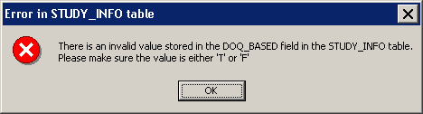
Error message – Not populated with a valid domain value.
Solution: When the tables are exported to dBase format, all of the domain codes are converted to domain values. In this case, the field was not populated with a valid domain code; thus, the tool is not able to translate it into a valid domain value. The exporting process will continue when you click OK. After the exporting process is complete, correct the error that the message refers to by selecting a valid value from the domain. Save your edits and repeat the database export.

Contacts
If you need assistance with this tool, please contact the representative at your local RMC.

